**Design Document**

1. **Functional Hierarchy**Also known as DFD, Data flow diagrams are used to graphically represent the flow of data in a business information system. DFD describes the processes that are involved in a system to transfer data from the input to the file storage and reports generation.  
   1. **DFD Level 0**The level 0 DFD gives a high-level overview of the project.  
      Figure one has the level 0 DFD for the project.

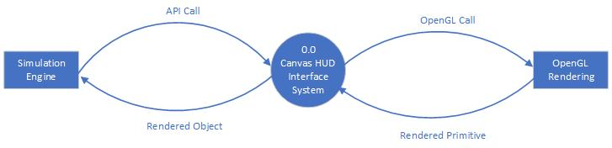  
Fig. 1: Level 0 DFD

* 1. **DFD Level 1**The level 1 DFD goes into greater detail regarding the functionality of the software. Figure 2 has the level 1 DFD of the project.

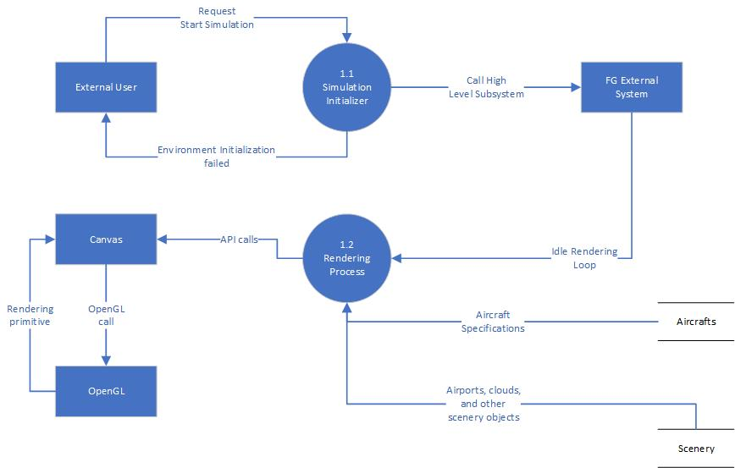

Fig. 2: Level 1 DFD